TECHNOLOGY

MT-1300 | Multi-functions Optical Time Domain Reflectometer

◆ 3.5 inch color TFT-LCD (touch screen)
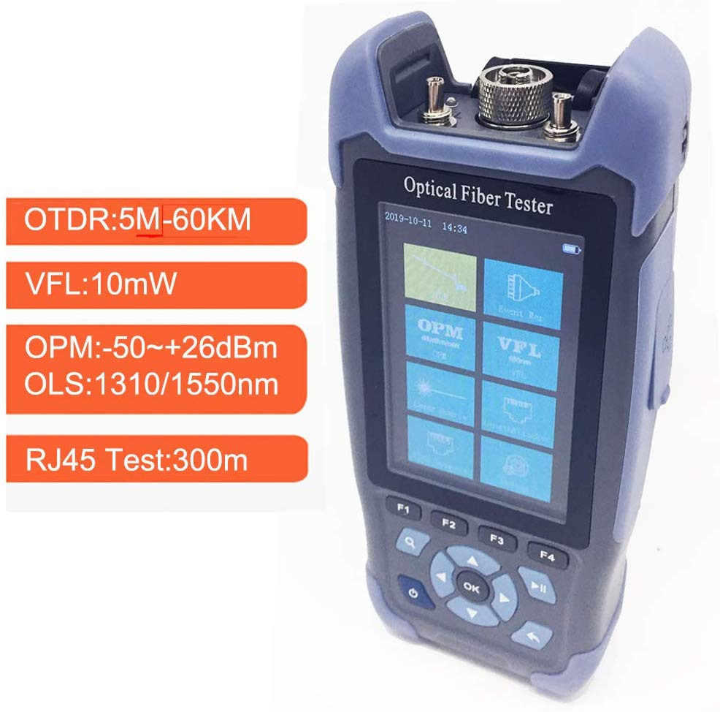
◆ Handheld design, light weight and easy operation
◆ Applicable fiber: SM
◆ Dynamic Range: 24/22dm
◆ RJ 45 cable TDR test, cable sequence test
◆ Optical power meter, Visual fault locator, Laser source
◆ Can create test report

MT-1300 hand-held optical time domain reflectometer is a high-performance, cost-effective optical network analysis barrier tester, with a lightweight, easy to use, highly intelligent, single-key automatic fast test and other notable features. The instrument is small, light weight, powerful, battery-powered. Easy to operate interface, touch screen and key panel can be achieved on the operation of the OTDR to meet the operating habits of different testers.

Features

- Display: 3.5 inch color TFT-LCD screen
- Handheld design, light weight and easy operation
- Single mode: 1310/1550 nm
- Dynamic range: 24 / 22dB (can test about 60 km)
- Automatic measurement mode: 1310/1550 nm dual wavelength can be tested simultaneously
- Applicable fiber: SM
- <8m extra-short event dead zone
- Wavelength: 1550nm
- Up to 24dB High Dynamic Range
- Distance Range: 4,8,16,32,64,128,256km
- Pulse width: 3ns-10us
- RJ45 cable TDR test & cable sequence test
- Optical power meter, Visual fault locator, Laser source
- Event Map, can display the length of the link, the type of event point and the position of break point.
- USB interfaces, supporting USB stick and printer and direct cable download to PC via ActiveSync
- LED light
- Built-in friendly-environment lithium battery with high capacity for over 12 hours of operating life

Specifications

Items |  | MT-1300 Plus
Dynamic range |  | 24/22dB
Wavelength (±20 nm) |  | 1310/1550
Display |  | 3.5 inch colorful TFT-LCD screen
Event dead zone |  | 3m
Attenuation Dead zone |  | 8m
Optical interface |  | FC/UPC(SC and ST are exchange)
Distance range |  | 500m-60km
Pulse width (ns) |  | 3ns-10us
Sampling point |  | 16k-256k
Sampling resolution |  | 0.05m-8m
Distance measurement precision |  | ±(1 m + 5 x 10-5 x Distance + Sampling interval)
Data storage |  | ＞500 test traces
Laser safety level |  | CLASS II
File form |  | SOR standard file form
Communication interface |  | USB
VFL | Wavelength | 650nm
 | Output power | 10mW
Optical Power meter | Wavelength | 850/1300/1310/1490/1550/1625nm
 | Testing range | -70dBm - +10dBm
Light source | Wavelength | 1310/1550nm
External power supply |  | DC 5V 2A
Battery |  | Built-in 3.7V Lithium polymer battery, 4000mAh
Operation time |  | normal working time 12 hours
Working Temperature |  | -10℃---+50℃
Working Humidity |  | 0 -95%
Dimension/Weight |  | 173mm x 82mm x 37mm / 0.4kg

Note:
- Technical specifications describe the guaranteed performance of the OTDR when a typical UPC connector is used for measurement. The uncertainty caused by the reflection ratio of the optical fiber is not considered. The MT-2300 is measured when the measuring range is 120km. the pulse width is 2560 ns, and the average time is 3 min.
- Dead zone measurement conditions: The reflection event occurs within 4 KM. The reflection strength is smaller than -45 Db. The minimum pulse width is used.

